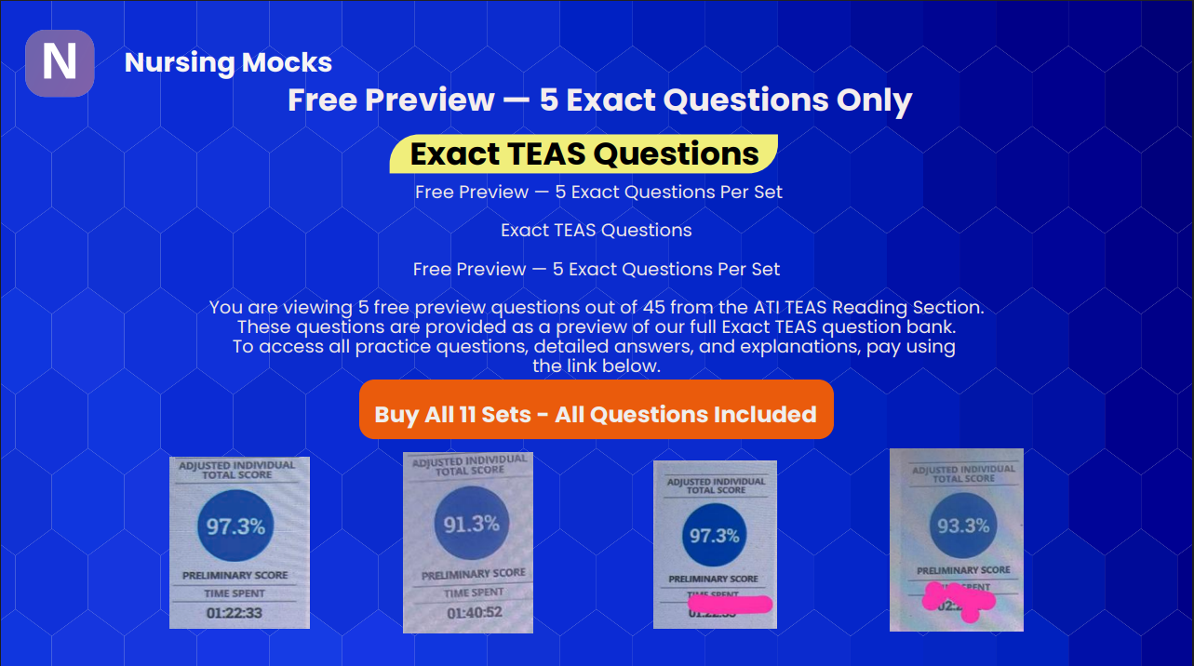

📘 READING

Question 3
Passage:
Research shows that tipping in a restaurant has little to no effect on service. What tipping does do is enable restaurateurs to pay less than the federal minimum wage to servers and depend on customers to make up the difference between servers’ salaries and the minimum wage. The U.S. federal minimum wage for servers is $2.13 per hour. Although minimum wage varies from state to state, it is safe to say that customers are paying the lion’s share of servers’ salaries. This practice leads to resentment on the part of customers, and it devalues servers. It’s time to abolish tipping and pay employees a living wage. The result may well be happy servers who provide excellent service to grateful customers.
Question:
Which of the following is the writer's main argument?
Options:
A. Customers are resentful of having to help pay the salaries of servers.
B. The federal rate for servers is too low.
C. Servers should provide excellent service no matter how much they make.
D. The custom of tipping should be abolished, and servers should be paid a living wage.
Correct Answer:
D. The custom of tipping should be abolished, and servers should be paid a living wage.

Question 4
Passage:
Research shows that tipping in a restaurant has little to no effect on service... (same passage as above)
Question:
Which of the following is evidence the writer provides to support the main argument?
Options:
A. Customers are grateful for excellent service.
B. Minimum wage varies from state to state.
C. Servers do not provide good service because of their low pay.
D. Customers pay a large percentage of servers’ salaries.
Correct Answer:
D. Customers pay a large percentage of servers’ salaries.

Question 5
Passage:
Excerpt from a suspense novel
Shia looked up from his monitor, rubbed his eyes, and stared down the dark hallway toward the CFO's office. He was certain a sound had come from behind the closed door. It was a heavy thump, like someone had dropped a bowling ball.
There shouldn't be anyone else here at this hour... (full passage continues as shown)
Question:
Which of the following contains only key points of the passage?
Options:
A. There is a thump like a dropped bowling ball, a loud crash, and shattered glass.
B. Shia is working at his computer, there is little light, and no one else should be in the building.
C. Shia is working late, he hears mysterious noises, and he is frightened enough to leave work.
D. There are frightening noises in the office, Shia goes home, Shia sends his boss a text.
Correct Answer:
C. Shia is working late, he hears mysterious noises, and he is frightened enough to leave work.

Question 6
Passage:
(same Shia passage)
Question:
Which of the following is the topic of the excerpt?
Options:
A. A building with poor lighting and security
B. A boss's expectations of an employee
C. A mysterious experience at work
D. An employee who is easily scared
Correct Answer:
C. A mysterious experience at work

Question 7
Passage:
(same Shia passage)
Question:
Which of the following is the tone of the passage?
Options:
A. Tense
B. Aggressive
C. Incredulous
D. Witty
Correct Answer:
A. Tense

Question 8
Passage:
(same Shia passage)
Question:
Which sentence supports that the passage takes place in the 21st century?
Options:
A. His office was on the thirtieth floor...
B. He sent his boss a single text message...
C. Shia ran to the parking garage...
D. Shia froze like Medusa...
Correct Answer:
B. He sent his boss a single text message...

Question 9
Passage:
(same Shia passage)
Question:
Which source would be best to find other suspense novels?
Options:
A. Encyclopedia entry
B. Library digital catalog
C. Bestseller list
D. Online reviews
Correct Answer:
B. Library digital catalog

Question 10
Passage:
An Interesting Birthday Party
On Saturday afternoon, local eccentric Dr. Oliver Creekstone held a remarkable 90th birthday party...
Question:
Which conclusion is supported?
Options:
A. He is carnivorous
B. Estate is small
C. Estate cannot hold more zebras
D. He is unconventional
Correct Answer:
D. He is unconventional

Question 11
Passage:
(same birthday passage)
Question:
Which quote contains a stereotype?
Options:
A. Party was well planned
B. Food was bad
C. I wouldn't want zebras
D. Considering his age, he was surprisingly intelligent
Correct Answer:
D. Considering his age, he was surprisingly intelligent

Question 12
Passage:
(same birthday passage)
Question:
Which word has a negative connotation?
Options:
A. Complimentary
B. Shocked
C. Reportedly
D. Contained
Correct Answer:
B. Shocked

📊 MATH

Question 2
Question:
What is the area of a square that measures 3.1 m on each side?
Options:
A. 9.61 m²
B. 9.1 m²
C. 6.2 m²
D. 12.4 m²
Correct Answer:
A. 9.61 m²

Question 6
Question:
Width = 4 in, area = 32 in². Find length.
Options:
A. 36 in
B. 8 in
C. 128 in
D. 28 in
Correct Answer:
B. 8 in

Question 10
Question:
74% + 3% + 2% → remainder?
Options:
A. 21%
B. 79%
C. 5%
D. 69%
Correct Answer:
A. 21%

Question 14
Question:
2.5 tsp → mL
Options:
A. 7.43
B. 5.33
C. 0.507
D. 12.325
Correct Answer:
D. 12.325

Question 19
Question:
0.0025 → %
Options:
A. 0.25%
B. 0.025%
C. 2.5%
D. 25%
Correct Answer:
A. 0.25%

🔬 SCIENCE

Question 5
Question:
What can space photos analyze?
Options:
A. Deforestation
B. Human movement
C. Whale migration
D. Hurricanes
Correct Answer:
A. Deforestation

Question 6
Question:
Property of water
Options:
A. 1 H + 2 O
B. Dissolves polar/ionic
C. Less heat than ethanol
D. Solid more dense
Correct Answer:
B. Dissolves polar/ionic

Question 9
Question:
Function of tendons
Options:
A. Bone → ligament
B. Bone → bone
C. Muscle → ligament
D. Muscle → bone
Correct Answer:
D. Muscle → bone

Question 10
Question:
RNA-only base
Options:
A. Uracil
B. Cytosine
C. Thymine
D. Adenine
Correct Answer:
A. Uracil

Question 13
Question:
Cartilage flap preventing food entry
Options:
A. Larynx
B. Epiglottis
C. Pharynx
D. Glottis
Correct Answer:
B. Epiglottis

✍️ ENGLISH

Question 1
Question:
"Singing is my favorite activity."
"Singing" is what part of speech?
Options:
A. Noun
B. Adverb
C. Preposition
D. Adjective
Correct Answer:
A. Noun

Question 2
Question:
Part of speech of "although"
Options:
A. Adverb
B. Participle
C. Interjection
D. Conjunction
Correct Answer:
D. Conjunction

Question 3
Question:
"Lively" part of speech
Options:
A. Adjective
B. Adverb
C. Conjunction
D. Interjection
Correct Answer:
A. Adjective

Question 4
Question:
"Intra-" meaning
Options:
A. Between
B. Around
C. Within
D. Against
Correct Answer:
C. Within

Question 5
Question:
Transition for comparison
Options:
A. Likewise
B. Therefore
C. In addition
D. For instance
Correct Answer:
A. Likewise

